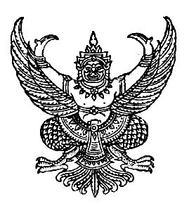

Announcement of kurah Subdistrict Administraive Organization
Subject: Policy of not accepting neither gifts nor profits from performing duties (No Gift Policy)
Fiscal year 2025
---------------------------------------------------
I’ Mr. Sujit Chamnankit, President of Namtok Subdistrict Administraive Organization As the highest executive of the kurah Subdistrict Administraive Organization, Thung Yai District, Nakhon Si Thammarat Province, I would like to announce a policy of not accepting gifts and all kinds of gifts from performing duties (No Gift Policy) and would like to announce the intentions of all executives, officials, and personnel of the organization Kurah Subdistrict Administraive Organization It is an organization in which all executive,officers, and personnel do not accept gifts and benefits of any kind while performing their duties (No Gift Policy) before, during, and after performing their duties. And that acceptance will result in corruption and misconduct both now and in the future. By working together to create a culture of honesty in the organization. Cultivate and raise awareness, create good attitudes and values in performing duties so that one can automatically think and distinguish between personal and public interests. and has a base of thinking that considers the public interest more than personal interest, has public spirit, performs official duties correctly, transparently, fairly and without discrimination Do not act in a conflict between personal interests and public interests. Do not accept property or any other benefits that may be calculated as income from anyone. apart from property or benefits that should be obtained according to laws, rules or regulations issued by virtue of the provisions of the law. Unless it is receipt of property or any other benefit in accordance whit ethics. According to the criteria and numbers set by the NACC, including conduct according to the ethical standards of government officials. and operating guidelines for giving or receiving gifts of other benefits of government officials of all positions and levels of the kurah Subdistrict Administraive Organization, as well as related laws, regulations, and Cabinet resolutions. Strictly so that the kurah Subdistrict Administraive Organization Free from corruption and misconduct
It is hereby announced and to adhered to all
This announcement is made on october 28 ,2025
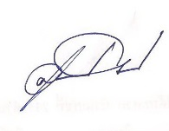

Mr. Sujit Chamnankit
President of kurah Subdistrict Administraive Organization

